15.66: (a) The string vibrates through 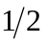cycle in 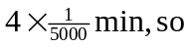

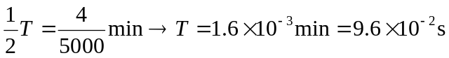

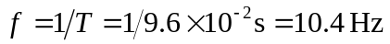

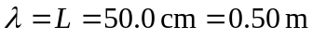

(b) Second harmonic

(c)
(d) (i)Maximum displacement, so 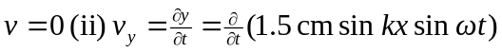

Speed 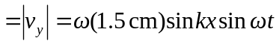

at maximum speed, 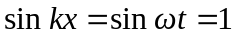

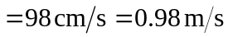

(e)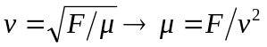
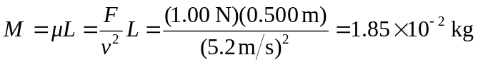
=18.5 g

